20BCE1837

EX No. 6

Date: 16.9.2022

AIM: To execute JavaScript functions in an HTML website.

Procedure:

1. Type the JavaScript functions and save in a .js file.

2. Link the .js file to the .html file.

3. Open the .html file inside a web browser.

CODE: styles.css

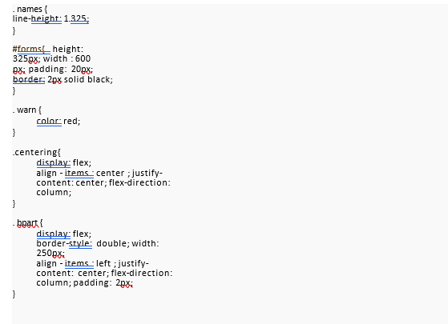

Index.html

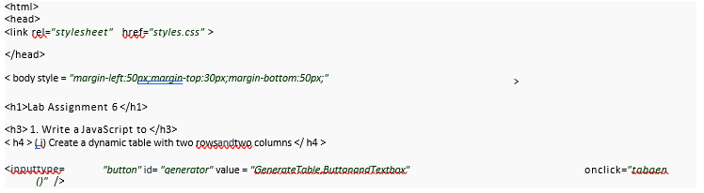

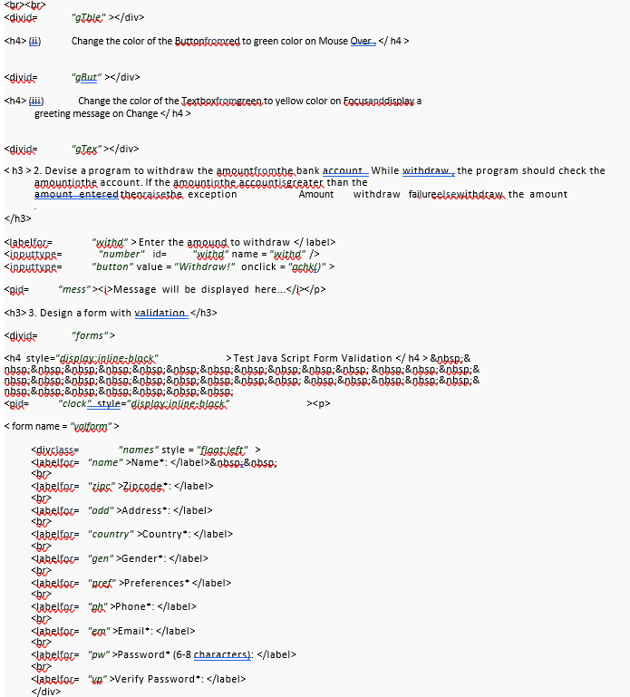

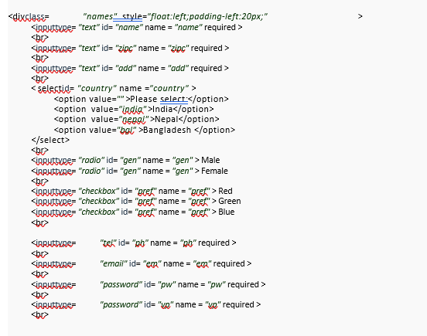

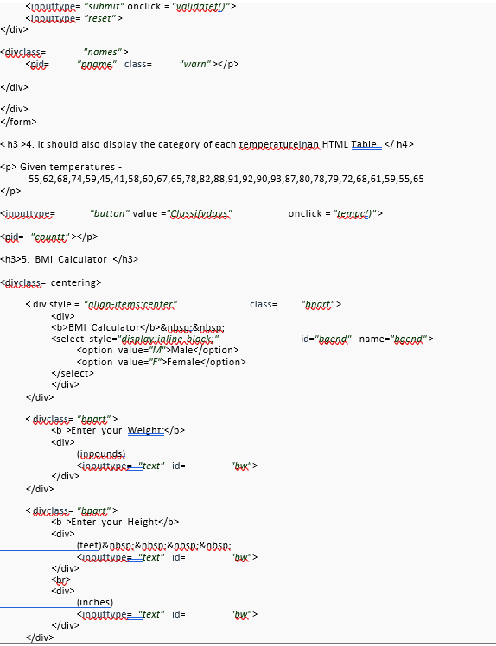

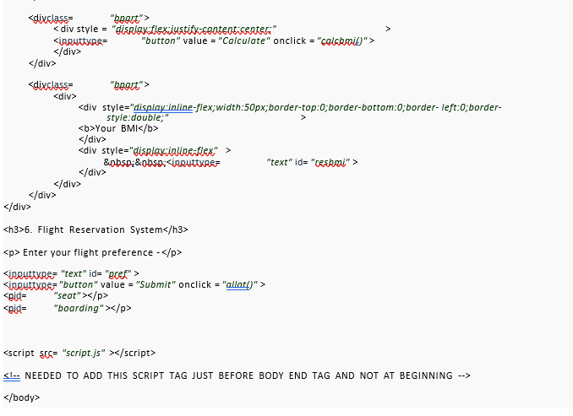

Script.js

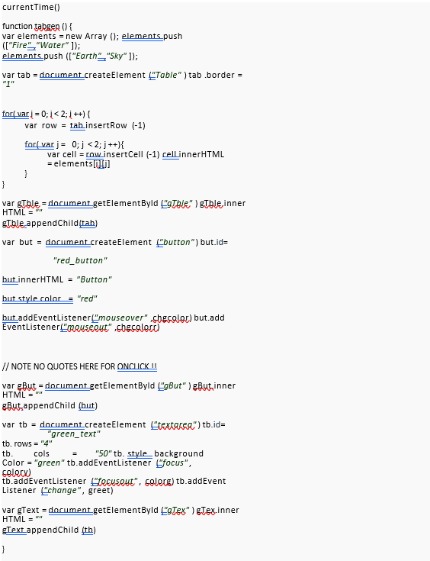

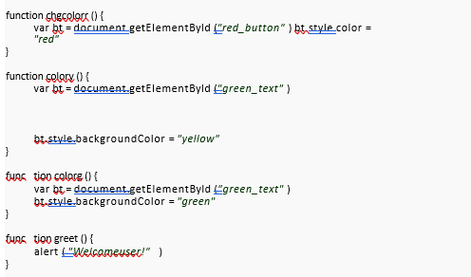

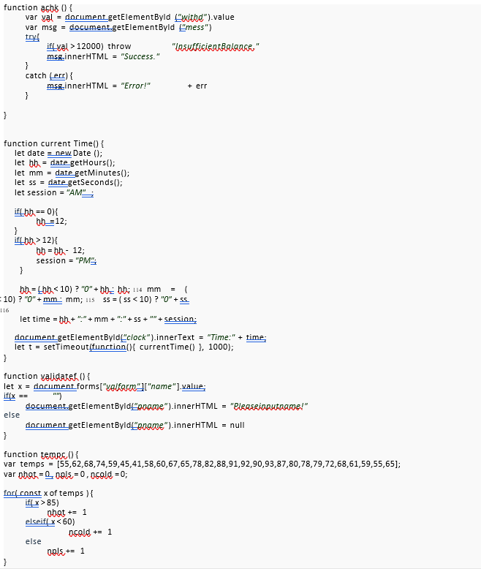

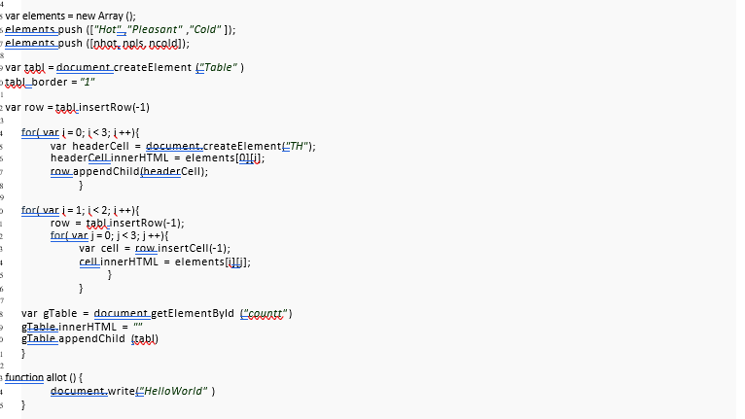

OUTPUT:

Question 1:

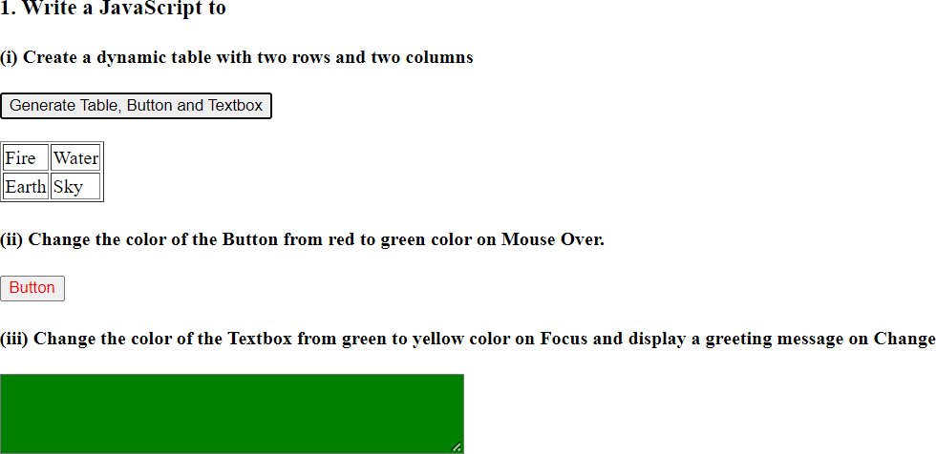

QUESTION 2:

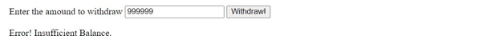

QUESTION 3:

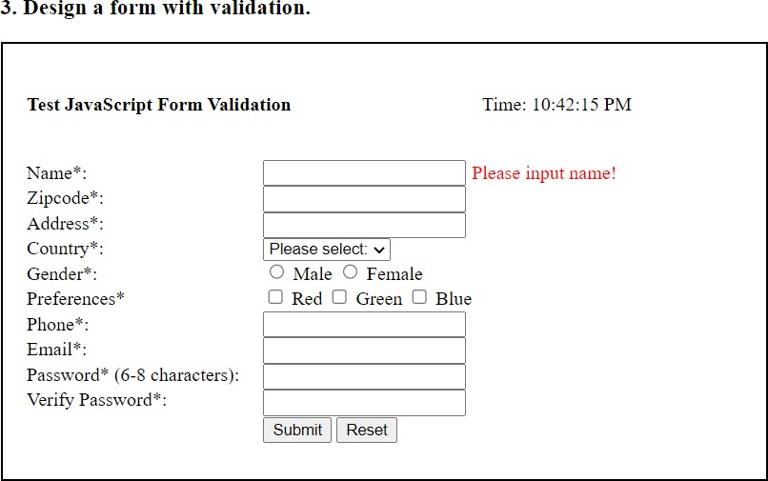

QUESTION 4:

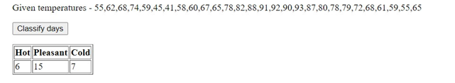

QUESTION 5:



QUESTION 6:



RESULT: Thus the Javascript Functions were successfully implemented.